CD Quartz Cocoa Lib User Guide.

Overview. 1

Project Repositories. 1

How to Build CD Quartz Cocoa Lib. 1

Overview.
This document provides details of how to incorporate this library into your own projects.

Project Repositories.

Project Name | Git Hub URL | Description
CDQuartzCocoaLib | http://github.com/cxd/CDQuartzCocoaLib | This is the main project.
CDGraph | http://github.com/cxd/CDGraph | This project contains the library CDGraph on which CDQuartzCocaLib depends.  This is located in a separate repository as it is shared by a separate project.

How to Build CD Quartz Cocoa Lib.

1 | Checkout a copy of CDGraph to a working directory.
2 | Open the CDGraph project in XCode and build it.
3 | Check out a copy of CDQuartzCocoaLib.
4 | Open the CDQuartzCocoa project in XCode.
5 | Adjust the project dependency for CDGraph.xcodeproj  Use Command-I to choose the correct path. | 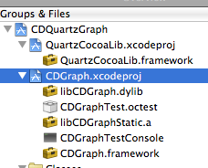
6 | Adjust the path to the CDGraph.framework in XCode.  The framework will be produced by building CDGraph.  It will be located in the CDGraph/build/Debug directory. | 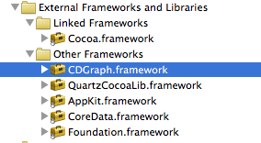
7 | Adjust the framework search paths.  Make sure that the target uses the correct search path for any dependencies. | 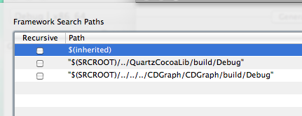
8 | Check include search paths.  Make sure they include the correct paths to CDGraph or CDGraphTouch if compiling a *Touch project. | 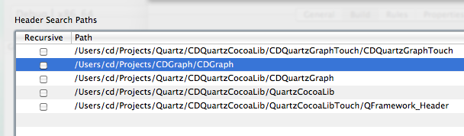
8 | Repeat the process for other projects within the CDQuartzCocoaLib project that have a dependency on CDGraph. | CDQuartzGraph  CDQuartzGraphTouch

